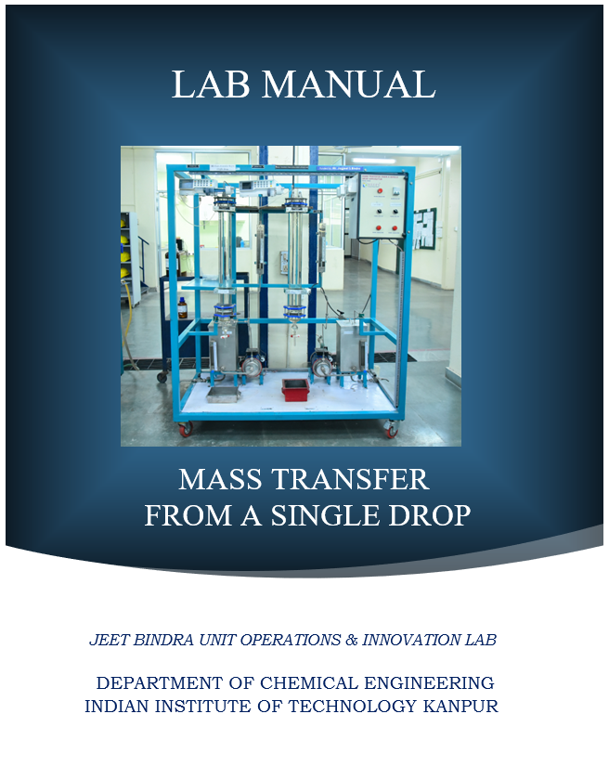

**INDIAN INSTITUTE OF TECHNOLOGY KANPUR**

**DEPARTMENT OF CHEMICAL ENGINEERING**

**Unit Operation Lab (ChE-492)**

Mass Transfer from a Single Drop

1. Objective:

1.1 To study the effect of drop size on the terminal velocity of the drops.

1.2 To study the effect of drop size on the overall and individual mass transfer coefficients.

1.3 To study the effect of drop formation on the overall mass transfer coefficient

2. Aim:

To determine the terminal velocity, individual and overall mass transfer coefficients for a single drop.

3. Introduction:

The motion of liquid drops in another liquid medium and the transfer of a solute from these drops to the surrounding fluid is an important topic of interest to chemical engineers. Real system of interest involve a large number of drops; nevertheless information obtained on the mass transfer rated from single drops is useful in the understanding of liquid-liquid extraction equipment, the contact between the two liquid phases is secured through the dispersion of one of the phases as drops. Hence, a knowledge of drop phenomena should provide the basic information needed for the design of most liquid-liquid contactors in which the drop size is related to the mass transfer rate and the terminal velocity to the capacity of the equipment.

4. Theory:

**Motion of drops:**

The study of the shapes of moving drops has been found useful in understanding the

dynamics of moving drops since the drag on the drops depends on their shapes during

movement in another medium. The shape of a liquid drop depends upon several factors such as the viscosity of the drop fluid, viscosity of the surrounding medium and the drop volume. Small drops are generally spherical. For large drops, the shape changes periodically from ellipsoidal to prolate (Laddha and Degaleesan, 1976).

A comparison with the fall of a solid sphere in a liquid would help in understanding the motion of drops in a fluid medium. The velocity of the fluid at the surface of a solid body is zero (no slip condition) but this is not the case for a liquid drop due to its mobility. In the latter case, only the normal velocity component is zero whereas the tangential velocity component is nonzero. In the liquid drops, the interfacial area is continuously changing, new area is being continuously created in the forward regions and equivalent area is being destroyed in the rear portion of the drop. This is called internal circulation and mass transfer increases due to this circulation. Very small drops at low Reynolds number settle in a manner similar to solid spheres and the terminal velocity increases with drop size. As the drop size is further increased, due to internal circulation, the terminal velocity attains a maximum value. After this peak point, further increase in drop diameter does not result in any appreciable change in the terminal velocity. Various correlations have been attempted to relate terminal velocity, drop size, peak velocity and maximum drop size to the physical properties of the system.

By considering the force balance on a moving spherical drop, it can be shown that

 (1)

where CD is the drag coefficient.

The following correlations have been suggested (Laddha and Degaleesan, 1976) for the drag coefficient for liquid drops:

 for < 12 (2)

and

 for >20 (3)

where







The interval 12 << 20 represents the peak velocity region.

**Mass Transfer from drops:**

A solute encounters three resistances as it transfers from the interior of the drop to the surrounding fluid. These are:

(i) The resistance encountered in the transfer from the bulk of the drop to the surface.

(ii) The resistance encountered in transfer through the interface.

(iii) The resistance encountered in the transfer from the interface to the bulk of the continuous phase.

If the drops are falling in a stagnant liquid column, then the concentration of solute in the dispersed phase will change along the column length. Let us consider the situation at a particular level in the column. Assuming that this solute is diffusing from the dispersed phase into the continuous phase, there must be a concentration gradient in the direction of mass transfer within each phase. This is graphically shown in Figure 1.

Dispersed

Phase Interface

CAc*i*

CAd*i*

CAd

CAc

Continuous

Phase

*Figure 1****:*** ***The two resistance concept***

The concentration of solute A in the main body of the drop is CAd and is assumed to be uniform due to internal circulation. This concentration falls to CAd*i* at the interface. In the continuous phase, the concentration falls from CAc*i* at the interface to CAc in the bulk liquid. It is generally assumed that there is no resistance to solute transfer across the interface separating the two phase as a result, CAd*i* and CAc*i* are equilibrium values, given by the system’s equilibrium distribution curve (Treybal, 1981).

The various concentrations can also be shown graphically as in Figure 2, whose coordinates are those of the equilibrium distribution curve.

Concentration of solute in dispersed phase kkl/m3)

P

Q

CAd

Equilibrium

CAd*i*

M

Distribution curve

C*Ad

B

C*Ac

CAc*i*

CAc

Concentration of solute in

continuous phase kmol/m3

(kmol/m3) 

Figure 2: Departure of bulk-phase concentration from equilibrium

Point P represents the two bulk-phase concentrations and point M those at the interface. For spherical drops, at steady state, we can write the rate of mass transfer of A in terms of individual or overall mass transfer coefficients as

 (5)

where C*Ad is the dispersed phase concentration which would be in equilibrium with CAc. Similarly C*Ac is the concentration which would be in equilibrium with CAd.

It can be shown that

 (6)

where m is the slope of the line joining points B and M (Figure 2). If the concentration of solute in the continuous phase is negligible, eqn (5) simplifies to

 (7)

or  (8)

Since mass is transferred as the drop falls down, CAd decreases from the top to the bottom of the column. Hence, we have to use the log mean concentration difference to evaluate the average rate of mass transfer. In such a case

 (9)

Where

 (10)

The total mass transferred, M, from a single drop is then

 (11)

where τ is the residence time of the drop.

Correlation for kd and kc

Several correlations have been proposed for estimating the individual mass transfer coefficients (Laddha and Degaleesan, 1976).

The following correlations have been reported from correlation of experimental data for single file drops:

 (12)

** ,**  (13)

For fully developed internal circulation the following correlations have been proposed,

  (14)

 (15)

**Effect of Drop Formation and Coalescence on Mass Transfer**

The mass transferred during drop formation before detachment of the drop from the dispersing nozzle is reported to form a major fraction of the total extraction, as observed in many investigations. This marked increase in the rate of mass transfer may be explained by considering the extent of internal circulation in the drop.

5. Experimental Apparatus and Procedure:

**Apparatus :**The apparatus consists of a glass column which is filled with either pure benzene or benzene containing some acetic acid. The dispersed phase consists of an aqueous solution of acetic acid. Drops of acetic acid-water are generated using nozzles of various diameters. The dispersed phase collected at the bottom can be withdrawn through an opening at the bottom of the column. Besides this, burettes, pipettes, beakers etc are required to perform the titrations.

6. Experimental Procedure:

1. Prepare an aqueous solution of acetic acid and determine its concentrations by titration (refer Appendix).
2. Fill the column with pure benzene.
3. Fill the burette/syringe with the aqueous acetic acid solution. This is the dispersed phase.
4. Adjust the nozzle/syringe needle approximately 2-3 cm above the level of the liquid in the column.
5. Now run down the liquid from the burette/syringe and check whether drops of approximately the same size are generated.
6. For approximately 2 ml of liquid running down (from burette/syringe reading). Count the number of drops. From this information, the drop radius can be calculated.
7. Determine the terminal velocity of the drops by measuring the time required for the drops to pass through a known distance (take the average for at least five drops).
8. Knowing the length of the benzene column and the terminal velocity, the residence time of the drops can be calculated.
9. After sufficient number of drops have passed through the continuous phase, stop the flow of the dispersed phase.
10. Remove the dispersed phase from the column bottom and determine its acetic acid concentration by titration.
11. Change the nozzle and repeat steps 3 to 9.
12. Drain the benzene from the column and fill the column with benzene which contains some acetic acid. Determine the acetic acid concentration in benzene by titration.
13. Repeat steps 3 to 10.
14. To see the effect of drop formation on the rate of mass transfer, repeat the experiment with the nozzle/needle immersed in the column liquid. Do this for one nozzle size and the column liquid filled with benzene-acetic acid solution.

7. Utilities Required:

1. Glass Column
2. Distilled Water (To Prepare Solution).
3. 5 Conical Flasks.
4. Measuring cylinder.
5. Stopwatch.
6. 3 Burettes.
7. CHEMICALS: Quantity:

N/10 Acetic Acid 100 ml

N/10 NaOH 100 ml

Ethyl Acetate 200 ml

Indicator (phenolphthalein

and methyl orange) Few drops

8. Observations and Calculations:

DATA:

Diffusivity of acetic acid in benzene at 20OC = 1.92 × 10-5 cm2/s

Density of Benzene at 20OC = 0.879 gm/ml

Viscosity of Benzene at 20OC = 0.647 cp

30OC = 0.561 cp

Viscosity of acetic acid-water solution at different concentration and temperature

(in millipoise)

|  |  |  |  |  |
| --- | --- | --- | --- | --- |
| **Temp. OC** | **Acetic acid, wt%** | | | |
| **10%** | **20%** | **30%** | **40%** |
| 25 | 10.65 | 12.50 | 14.50 | 16.55 |
| 30 | 9.55 | 11.10 | 12.90 | 14.75 |
| 35 | 8.55 | 10.00 | 11.50 | 13.15 |

Density of acetic acid-water solution at different concentrations and temperature

(in gm/ml)

|  |  |  |  |  |
| --- | --- | --- | --- | --- |
| **Temp. OC** | **Acetic acid, wt%** | | | |
| **10%** | **20%** | **30%** | **40%** |
| 25 | 1.0107 | 1.0235 | 1.0350 | 1.0450 |
| 30 | 1.0089 | 1.0210 | 1.0320 | 1.0446 |
| 35 | 1.0042 | 1.0153 | 1.0338 | 1.0338 |

Distribution of acetic acid between benzene and water at equilibrium at 25OC

(data in wt%)

|  |  |  |  |  |  |
| --- | --- | --- | --- | --- | --- |
| **Upper Phase** | | | **Lower Phase** | | |
| **Acetic Acid** | **Benzene** | **Water** | **Acetic Acid** | **Benzene** | **Water** |
| 0.150 | 99.849 | 0.001 | 4.560 | 0.400 | 95.400 |
| 1.400 | 98.560 | 0.040 | 17.700 | 0.200 | 82.100 |
| 3.270 | 96.620 | 0.110 | 29.000 | 0.400 | 70.600 |
| 13.300 | 86.400 | 0.400 | 56.900 | 3.300 | 39.800 |
| 15.000 | 84.500 | 0.500 | 59.200 | 4.000 | 36.800 |
| 19.900 | 79.400 | 0.700 | 63.000 | 6.500 | 29.600 |
| 22.800 | 76.350 | 0.850 | 64.800 | 7.700 | 27.500 |
| 31.000 | 67.100 | 1.900 | 65.800 | 18.100 | 16.100 |
| 35.300 | 62.200 | 2.500 | 64.500 | 21.100 | 14.400 |
| 37.800 | 59.200 | 3.000 | 63.400 | 23.400 | 13.200 |
| 44.700 | 50.700 | 4.600 | 59.300 | 30.000 | 10.700 |
| 52.300 | 40.500 | 7.200 | 52.300 | 40.500 | 7.200 |

**Observation:**

1. Standardization of NaOH

Vol. of HCl = Normality of HCl =

Vol. of NaOH =

2. Initial concentration of solute

|  |  |  |  |
| --- | --- | --- | --- |
| Continuous Phase | | Dispersed Phase | |
| Volume taken | NaOH Required | Volume taken | NaOH Required |
|  |  |  |  |

*(Not necessary for pure benzene)

3. Temperature =

Liquid height in column =

4. Terminal Velocity

Time required to pass between two marks distance between the marks

5. Final concentration and drop volume

No. of drops Total volume of Volume of dispersed Volume of

required Dispersed phase phase taken for NaOH

collected titration for

Neutralization

9. Results:

1. Calculate the drops size of each nozzle assuming the drop to be spherical.

(volume of liquid collected = no.of drops x )

**9.2.** Calculate the terminal velocity and the average residence time of the drops in the column.

**9.3.** Compare the calculate Ut with that calculated using equation (1) and (2) or (3).

**9.4.** Calculate the number of drops constituting the total amount of liquid run down. From this and the initial and final concentration of the acetic acid in the dispersed phase, calculate the total mass transfer (M) and the average rate of the mass transfer for a single drop (NAv)

**9.5.** Calculate Kod from equation (9).Note that when the continuous phase is pure benzene Kod is equal to kd. Knowing kd and the Kod calculated for the case of benzene-acetic acid as the continuous phase, k­­c can be calculated from equation (6) for the two drop sizes. ‘m’ can be determined by plotting the equilibrium data given in the form of Figure 2. In Figure 2, concentrations are in the units of kmol/m3, whereas the equilibrium data in the appendix are in weight %.

**9.6.** Calculate kc, kd and Kod using equations (12), (13) and (6) and compare with experimental values

**9.7.** Calculate kc, kd and Kod using equations (14), (15) and (6) and compare with

experimental values

**9.8.** Calculate the percentage change in Kod for the case when the drops are formed in

the column rather than in air.

**Estimation of Acetic Acid :**

a) Acetic Acid can be estimated using NaOH of known strength, with phenolphthalein as indicator. This indicator is colorless in acidic medium and pink in alkaline medium.

b) The NaOH solution is first standardized using a standard HCl solution. For this titration, methyle orange is used as an indicator. Methyl orange is red in acidic medium and yellow in alkaline medium.

c) Note that only a few drops of NaOH will be required to titrate the acetic acid in benzene rich phase.

9. Nomenclature:

CAc  = Concentration of A in the continuous phase, kmol/m3

CAc*i* = Interface Concentration of A in the continuous phase, kmol/m3

CAd  = Concentration of A in the dispersed phase, kmol/m3

CAd*i* = Interface Concentration of A in the continuous phase, kmol/m3

C*Ac = Concentration which would be in equilibrium with CAd, kmol/m3

C*Ad = Concentration which would be in equilibrium with CAc, kmol/m3

CD = Drag co-efficient, dimensionless

ΔClm = Log mean concentration difference, defined in eqn (10), kmol/m3

Dc = Diffusivity of solute in the continuous phase, m2/s

Dd = Diffusivity of solute in the dispersed phase, m2/s

dp = Diameter of spherical drop, m

g = Acceleration due to gravity, m2/s

kc = Individual continuous phase mass transfer co-efficient, m/s

kd = Individual dispersed phase mass transfer co-efficient, m/s

Koc = Overall continuous phase mass transfer co-efficient, m/s

Kod = Overall dispersed phase mass transfer co-efficient, m/s

M = Total amount of solute transferred, kmol

m = slope of the chord of the equilibrium distribution curve,

dimensionless

NA = Rate of mass transfer, kmol/s

Nav = Average rate of mass transfer, kmol/s

NRe  = Reynolds Number, 

(NSc)c = Schmidt Number based on continuous phase properties, (μc/ρcDc)

(NSc)d = Schmidt Number based on dispersed phase properties, (μd/ρdDd)

NWe = Weber number, 

S = , dimensionless

Ut = Terminal Velocity, m/s

γ = Interfacial tension, N/m

ρc = Density of continuous phase, kg/m3

ρd = Density of dispersed phase, kg/m3

μc = Viscosity of continuous phase, Pa.s

μd = Viscosity of dispered phase, Pa.s

τ = Average residence time of drops, s

10. References:

1. Laddha, G. S. and Degaleesan, T. E., ‘Transport Phenomena in Liquid Extraction’, Tata McGrow-Hill, New Delhi, 1976
2. Treybal, R. E., ‘Mass Transfer Operations’, 3rd edition, McGrow-Hill International Book Co., Tokyo, 1981.

11. Questions:

1. Would the overall mass transfer coefficient remain the same if water was the continuous phase and acetic acid benzene solution was in the dispersed phase?

2. What are the implicit assumptions in equations (5) and (9)?

3. How is Koc related to kc and kd?

4. What is the Marangoni effect?

